

Project Title :
Population vs Literacy Rate
Correlation
Course:
Intro To Data Science
Group Member:
Sufyan Ghani
Roll No 29
Instructor:
Mr Bilal Ahmed
Class:
BS DS 4th

Department of Data Science
University of Kotli Ajk

1. Abstract

This project analyzes the relationship between population and literacy rate to understand how population growth affects education levels. The study uses secondary demographic data and applies correlation analysis to identify trends between population size and literacy rate. Tools such as MS Excel RapidMiner were used for data preprocessing, visualization, and statistical analysis. Graphs and correlation coefficients were generated to interpret the relationship.

2. Introduction

Population growth and literacy rate are two important indicators of a country’s socio-economic development. Literacy plays a vital role in improving living standards, employment opportunities, and national progress. This project focuses on examining whether population size has an impact on literacy rate. Understanding this relationship helps governments and policymakers design better educational strategies. The project demonstrates how data analysis techniques can be applied to real-world demographic data.

3. Objectives

- To study population and literacy rate data
- To analyze the correlation between population size and literacy rate
- To visualize trends using graphs and charts
- To interpret results for educational and social planning

4. Tools & Software Used

Tool Software Version Purpose
MS Excel 2019 / 2021 Data entry, cleaning, and graph plotting
RapidMiner Studio 9.x Correlation analysis and visualization
Dataset Source Kaggle CSV Population and literacy data

5.Data Analysis

- Data collection
- Data preprocessing
- Correlation analysis
- Graphical visualization

6. Device List

Device Name Purpose
Computer / Laptop Data analysis and report preparation
Internet Dataset collection

7. Implementation Steps

- Collect population and literacy rate data from reliable sources.
- Import the dataset into MS Excel RapidMiner.
- Clean the data by removing missing or incorrect values.
- Apply correlation analysis to find the relationship.
- Generate scatter plots and line graphs.

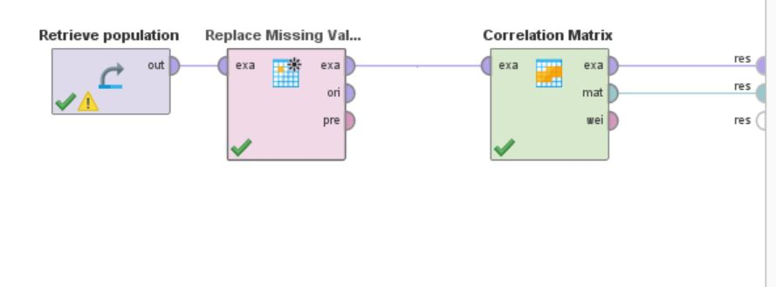

8. Simulation & Testing

- Correlation coefficient was calculated to test the strength of the relationship.
- Scatter plots were used to visually verify trends.
- Multiple regions years were tested to ensure accuracy.
Scatter Plot Graph

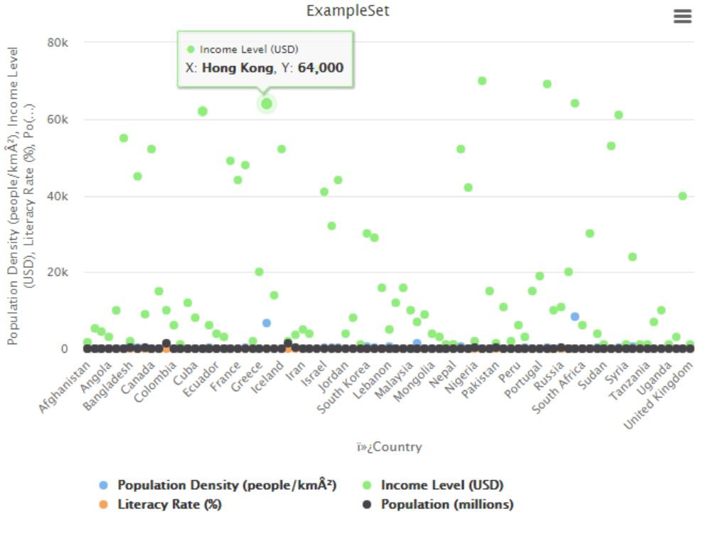

Correlation Analysis
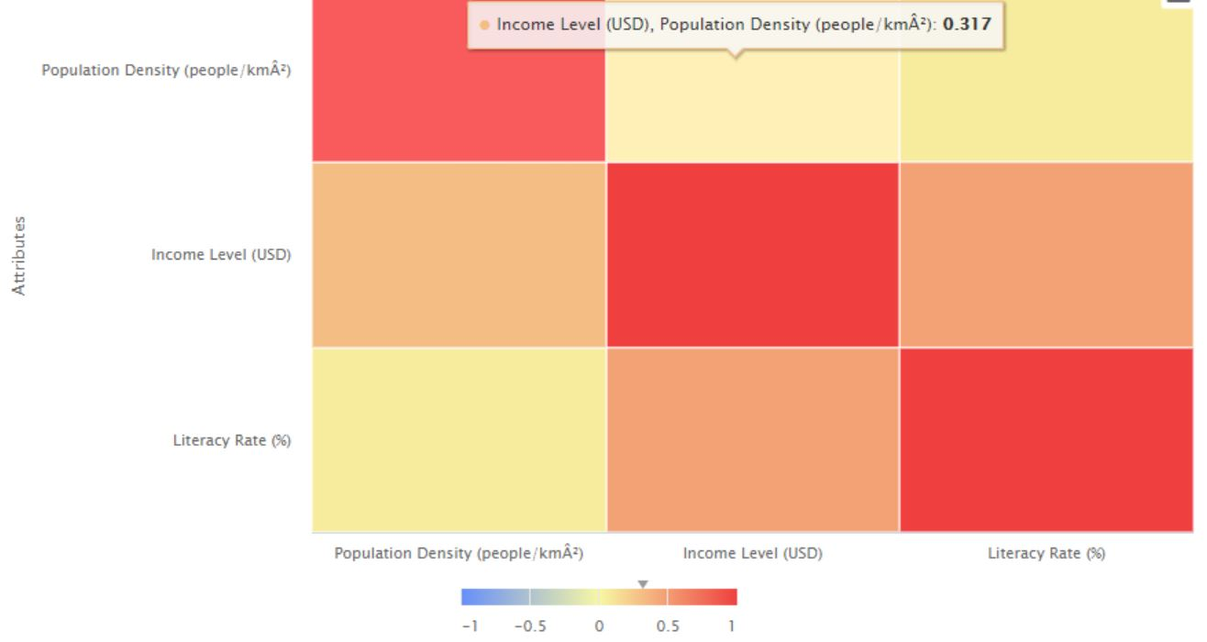

9. Results & Discussion

The results show a noticeable correlation between population and literacy rate. In regions with better educational infrastructure, literacy remains high despite population growth. However, in highly populated areas with limited resources, literacy rates tend to be lower. Data quality and availability were minor challenges, resolved by using trusted sources and data cleaning techniques.

10. Conclusion

This project successfully analyzed the correlation between population and literacy rate using data analysis tools. It improved understanding of how demographic factors influence education levels. The study highlights the importance of investment in education for growing populations. Future improvements may include using larger datasets, advanced statistical models, or machine learning techniques.
11. References
1. World Bank Population & Literacy Data
2 .Kaggle CSV Dataset
3. RapidMiner Documentation
4. Statistics and Data Analysis Textbook

